MUSICOLOGICAL GROUP
We are team Musicological. This is the documentation of the project we have done. The main purpose of this project is to give idea for the viewer about the top ratings of the movies we have in our database .
Since this is kind of personal favorite movie blog, we don’t have the option in which the viewer must have log-in account in order to vote for a movie. Hence, the viewer can up vote for the movie that he likes as much as he wants and down vote for others. However, the vote will be saved in our database and won’t disappear even refreshing the page. So any guest who passes by our movie blog always knows top 3 trending movies by the total number of votes for top 3 movies and the chart. Please note this chart is only for up-vote because we just want to see how much people like that particular movie.
In addition, if the viewer would like to know more information of the movie, he can click on the image of the movie, and there is a message info pop-up. This message includes the rating film system(PG-13, R…)duration, cast of the movie, any nomination achieved,etc...Another feature we added to our blog is when clicking to left or right arrow, the 3 movies is fading the opposite side within .5 seconds.
Below is our initial draft for the project that we think you will be interested to take a look.
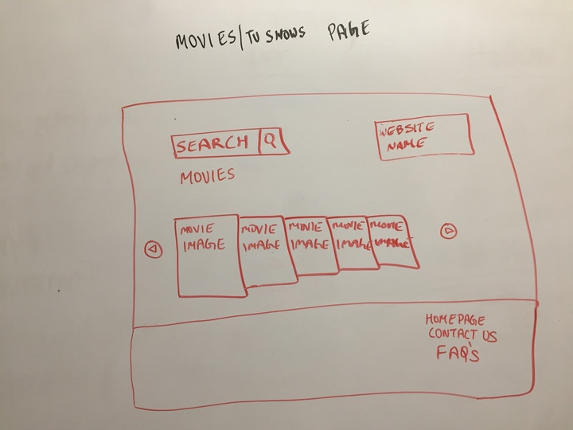

Fig 1
Fig1: This is the homepage of the website. We dropped idea of searching movies. We have 12 movies instead.

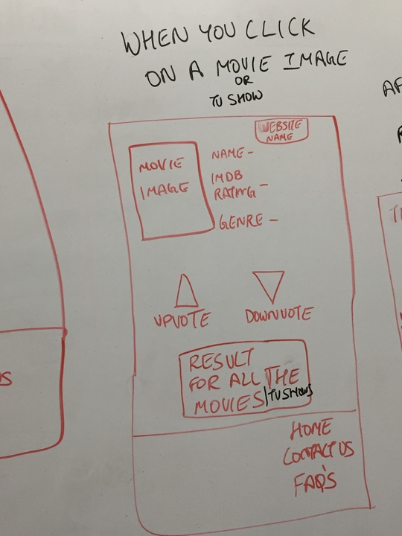

Fig 2
Fig 2: Each movie image should have detail information of the movie. 2 vote buttons and show result.
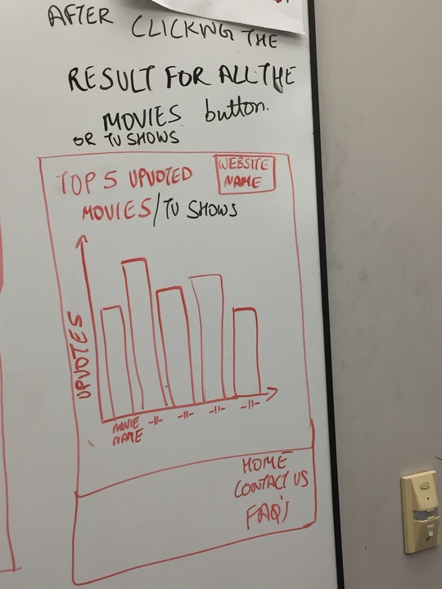

Fig 3
Fig 3: Actual showing the top 3 movies (instead of 5) with the up-votes only

In conclusion, we are trying to keep in track with our original plan and make the project simple, straight forward.

